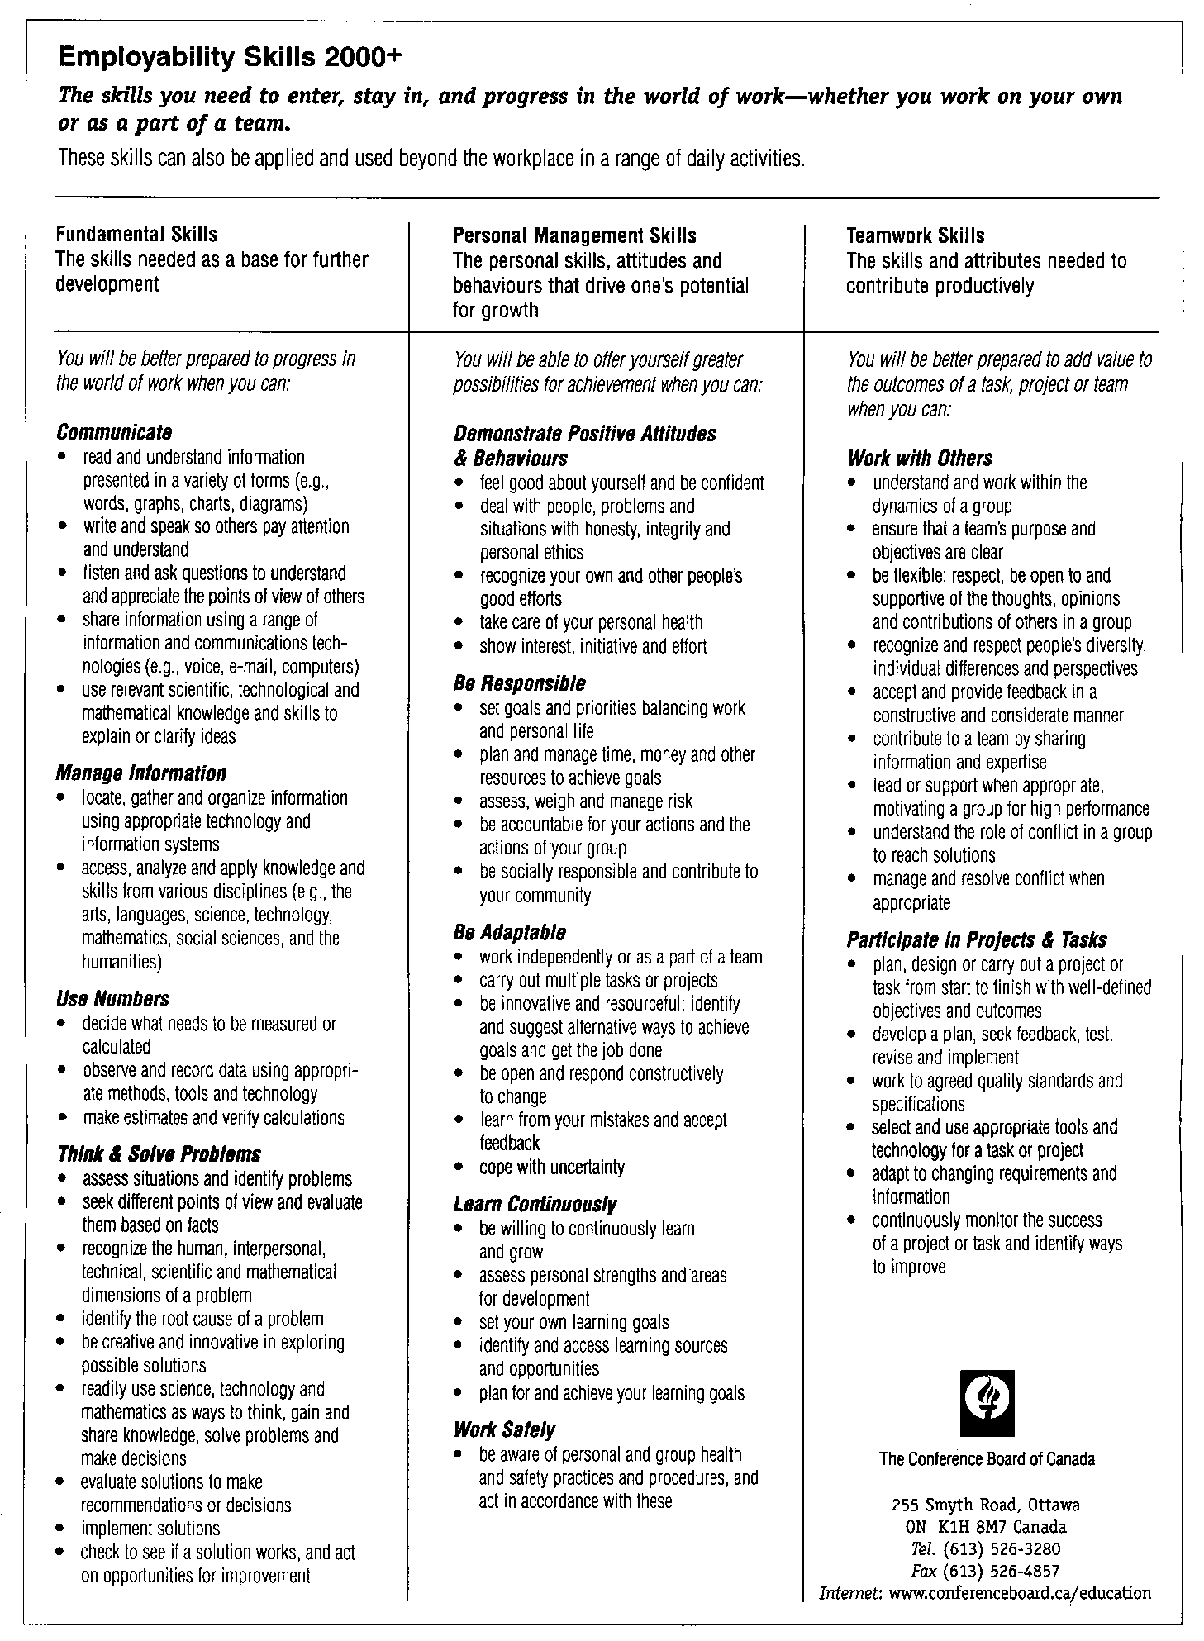
Employability Skills 2000⁺ Brochure 2000 E/F (Ottawa: The Conference Board of Canada, 2000)

