The following “age pyramid” chart shows how Canada’s population has been aging.

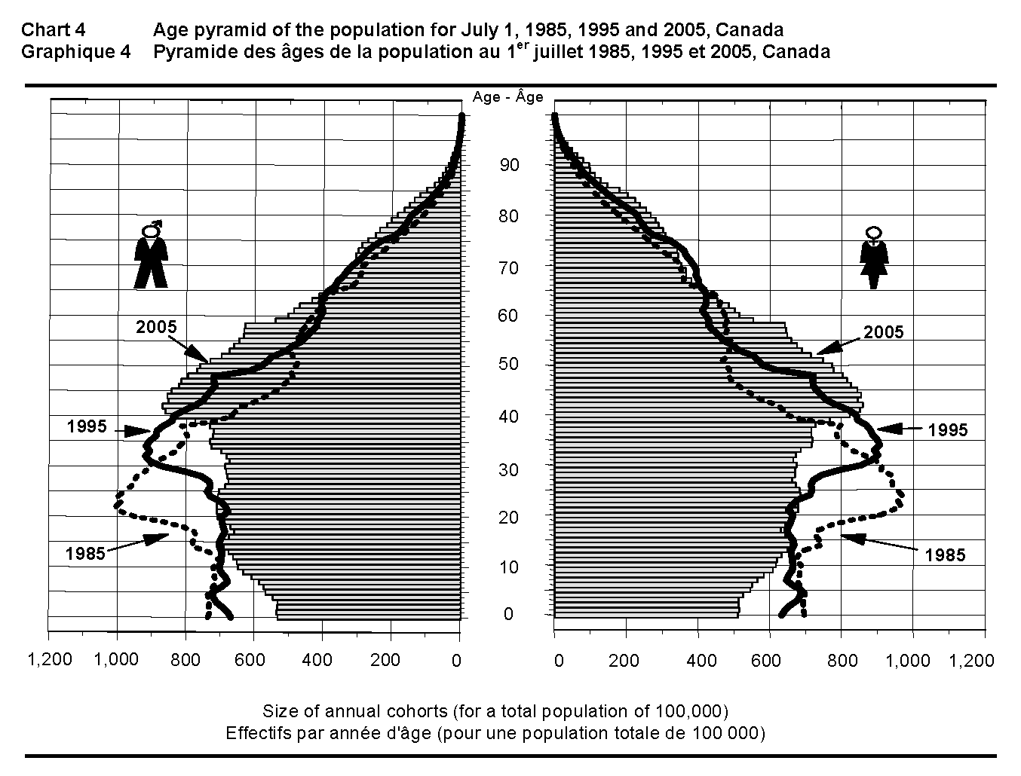
Source: Statistics Canada. Annual Demographic Statistics 2005 = Statistiques démographiques annuelles 2005.
Catalogue no. 91-213-XIB. Ottawa, ON: Statistics Canada, 2005. 6.
Statistics Canada information is used with the permission of Statistics Canada. Users are forbidden to copy the data and redisseminate them, in an original or modified form, for commercial purposes, without permission from Statistics Canada. Information on the availability of the wide range of data from Statistics Canada can be obtained from Statistics Canada’s Regional Offices, its World Wide Web site at www.statcan.gc.ca, and its toll-free access number 1-800-263-1136.
Look across the chart at various ages to see the differences in population in the different years.

The Impact of Demographics on Employment
The composition of society affects the need for goods and services industries.
Baby Boomers
The “baby boomer” population has influenced the growth in fitness and leisure activities, the purchase of educational technology at home and at work, the emphasis on health care, prevention-related goods and services, and holistic alternative forms of medicine.
Baby Boom Echo
The children of baby boomers have affected the changes in the children’s market for clothing, toys, music, and books.
The Blessed Ones
As sophisticated shoppers at the top of their income-earning power, they emphasize value over conspicuous consumption. They have created a niche market for RSSP, mutual funds, estate planning, and home renovations (to increasingly accommodate aging and disabled occupants). They offer unprecedented opportunities for companies that can offer them the kind of goods and services they will want and need.
Golden Oldies
The population over 65 has changed our emphasis on health care, and the technology, goods, and services related to that care. In addition, home care and community care services have changed and increased. These changes will continue to influence the labour market, as the baby boomers reach retirement.
Cultural Diversity
The cultural diversity in Canada today affects products and services geared to visible minorities, immigrants, and refugees. Services may include language training, translation services, and immigrant settlement services. Products may be geared to specific groups or subsets of the market (e.g., language-specific newspapers and television programs, food services and goods). Ethnic diversity has led to growth in a number of industries and occupations.
Can you think of industries or occupations that may be affected by baby boomers? by cultural diversity? Discuss.

Labour Market Supply
The supply of workers to fill jobs in the labour market is related to three factors:
- birth rate: Canada’s birth rate is below replacement level.
- labour force growth: Canada’s population is aging, and both the rate and absolute level of increase in the labour force will slow.
- rate of immigration: Immigration can help to minimize the population decline, but cannot realistically offset the shifting age structure of Canada. Total immigrant arrivals for Canada in 1994 did not meet the target 250 000 level planned by the federal government.
Immigration
New immigrants will take longer to adjust to the labour market because of a number of basic adaptation needs (Immigrant Services Society of BC):
- survival needs: food, shelter, clothing, language, health care orientation
- safety needs: adjustment/settlement counselling (trauma, culture shock), interpretation, translation, employment preparation, legal orientation
- social needs: being accepted and belonging
- esteem needs: gaining approval, respect, and access to programs and services
Designated Groups
The inclusion of groups that have been under-represented in the labour market, and the limitation of certain groups formerly overrepresented in the market, will have an impact on the number of workers and types of skills available to employers. The inclusion of people with disabilities will bring about a change in the work environment and in the attitudes of co-workers and employers. Changes will affect hiring procedures, and thus rearrange the composition of the labour force. If Canada is to have a labour force skilled enough to compete in the global economy, it is necessary to make effective use of all our human resources. Regulations are now being reviewed to improve legislation that helps employers identify and eliminate barriers to employment for designated group members: Aboriginal people, persons with disabilities, visible minorities, and women.
The Employment Equity Act is the current legislation in effect to administer and implement inclusive recruitment and retention in personnel practice. The Act ensures that employers with 100 or more employees prepare and carry out action plans to achieve a workforce in which designated group members are fairly represented.
The intent of employment equity is also to increase representation of the designated groups in occupational groups. A classic example of this is women in non-traditional occupations and in higher level management positions. Traditionally, women have been excluded from these types of positions because of their gender, not their ability. The purpose of the Act is remedial and not intended as punitive in any way towards any groups traditionally in these occupations.
Employment equity provides a new context in that the pool of applicants for jobs and for promotions will become more competitive, with more inclusive advertising and recruitment. Employment equity is sometimes blamed for problems related to the labour market, problems that are not related to equity initiatives and strategies.
What are the implications for employment for people from the designated groups? What are the implications for employment for people not in the designated groups? Discuss.

